**///// Gravity Forms \\\\**



Biggest era of WordPress Form Solutions

(Create Any Custom Form That You Can Visualize)

**====/////====/////====/////====/////====**

## **Gravity Form Plugins and Addons:** <https://developerszone.net/gravity-forms-plugins-and-addons/>

## **/////G\\\\ Single Topic Wise Video :**

* **Gravity Form SIMPLE CONTACT FORM** <https://youtu.be/w9qGjZqqYXY>
* **Gravity Form MULTI SECTION FORM:** [**https://youtu.be/oEFJQOtatIU**](https://youtu.be/oEFJQOtatIU)
* **Gravity Form MULTI STEP FORM:** <https://youtu.be/3-OnCWIf04g>
* **Gravity Form SETTINGS/CONFIRMATION/ ADMIN MAIL** <https://youtu.be/jOJ4lNd6G74>
* **Gravity Form POP UP:** <https://youtu.be/39pOiUok4Is>
* **Gravity Form MAILCHIMP:** [**https://youtu.be/qawguiqebVo**](https://youtu.be/qawguiqebVo)
* **Gravity form STYLER PRO:** <https://youtu.be/NgA7w7Zm53c>
* Gravity **Form PRODUCT PRICE CALCULATION(PAYPAL):** [**https://youtu.be/3-LdOP2Ofv0**](https://youtu.be/3-LdOP2Ofv0)
* Gravity **Form - ADVANCED PAYPAL + STRIPE PAYMENT(LOGIC)**:: <https://youtu.be/XPms8uwsiyM>
* **Gravity Form Quiz:** <https://youtu.be/MsEpWF-n32U>
* Gravity **PDF & PDF Download:** <https://youtu.be/I_LwH9L3-BE>
* Gravity **Form Image Choice:** [**https://youtu.be/y-NKBLce17I**](https://youtu.be/y-NKBLce17I)
* Gravity **Form Conditional Logic(medical admission form):** [**https://youtu.be/OSpl_PiHi5g**](https://youtu.be/OSpl_PiHi5g)

**/////G\\\\ Gravity Form License Activate :**

1. After form plugin install & activate > click “Form” > all form >
2. Keep license field “Blank” > next
3. You will see license is enabled
4. Next > next > create a form

# **/////G\\\\ Gravity Form Insert at web page :**

**Form insert option-01 (by shortcode & form id) :**

[gravityform id="1" title="true" description="true" ajax="true"]

**Form insert option-02 (by Essential Addons Elementor & Insert & Customize form) :**

# **/////G\\\\ Get Essential Addons Elementor :**

<https://mega.nz/file/KWpQQACb#_LbBU8IJUOtLgYUB2iFpb4guKOPdsBDVHI0dP77qNC0>

**\*\*\* This is 3rd party addons of elememtor : https://essential-addons.com/elementor/**

**\*\*\* By this you can customize any wp form by elementor**

**\*\*\* must need essential addons premium version + elementor + elementor pro**

## **/////G\\\\ How insert & customize by elementor & essential addons :** - এলিমেন্টর & এলিমেন্টর প্রো & এসেনটিয়াল অ্যাড-অন্স প্রিমিয়াম প্লাগিন লাগবে - এলিমেন্টর & এলিমেন্টর প্রো & এসেনটিয়াল অ্যাড-অন্স প্রিমিয়াম প্লাগিন লাগবে

- ফর্ম বিল্ডার দিয়ে ফর্ম বানানো (যেমন প্লাগিন দিয়ে ফর্ম বানাবো )

- পেজ ডিসাইন এর সময় এলিমেন্টর দিয়ে - "গ্রাভিটি ফর্ম " widget দিয়ে বানানো ফর্ম পেজ এ ইন্সার্ট করবো (এটা এসেনটিয়াল অ্যাড-অন্স এর widget )

- এবার এলিমেন্টর দিয়ে মন মতো ফর্ম এর সব ফিল্ড ডিসাইন করবো

*** গ্রাভিটি Formv এর নিজের ও এমন কাস্টোম কোনো প্লাগিন নাই ডিসাইন এর জন্য

*** কন্ট্যাক্ট ফর্ম ৭, WP -FORM, ninja form, মাইলচিম্প ফর্ম এর জন্য - একই ভাবে এসেনটিয়াল অ্যাড-অন কাজ করে ।

- এলিমেন্টর & এলিমেন্টর প্রো & এসেনটিয়াল অ্যাড-অন্স প্রিমিয়াম প্লাগিন লাগবে

- ফর্ম বিল্ডার দিয়ে ফর্ম বানানো (যেমন প্লাগিন দিয়ে ফর্ম বানাবো )

- পেজ ডিসাইন এর সময় এলিমেন্টর দিয়ে - "গ্রাভিটি ফর্ম " widget দিয়ে বানানো ফর্ম পেজ এ ইন্সার্ট করবো (এটা এসেনটিয়াল অ্যাড-অন্স এর widget )

- এবার এলিমেন্টর দিয়ে মন মতো ফর্ম এর সব ফিল্ড ডিসাইন করবো

*** গ্রাভিটি ওরম এর নিজের ও এমন কাস্টোম কোনো প্লাগিন নাই ডিসাইন এর জন্য

*** কন্ট্যাক্ট ফর্ম ৭, WP -FORM, ninja form, মাইলচিম্প ফর্ম এর জন্য - একই ভাবে এসেনটিয়াল অ্যাড-অন কাজ করে ।

- ফর্ম বিল্ডার দিয়ে ফর্ম বানানো (যেমন প্লাগিন দিয়ে ফর্ম বানাবো )

- পেজ ডিসাইন এর সময় এলিমেন্টর দিয়ে - "গ্রাভিটি ফর্ম " widget দিয়ে বানানো ফর্ম পেজ এ ইন্সার্ট করবো (এটা এসেনটিয়াল অ্যাড-অন্স এর widget )

- এবার এলিমেন্টর দিয়ে মন মতো ফর্ম এর সব ফিল্ড ডিসাইন করবো

*** গ্রাভিটি ওরম এর নিজের ও এমন কাস্টোম কোনো প্লাগিন নাই ডিসাইন এর জন্য

*** কন্ট্যাক্ট ফর্ম ৭, WP -FORM, ninja form, মাইলচিম্প ফর্ম এর জন্য - একই ভাবে এসেনটিয়াল অ্যাড-অন কাজ করে ।

## **/////G\\\\Form Level & Placeholder :**

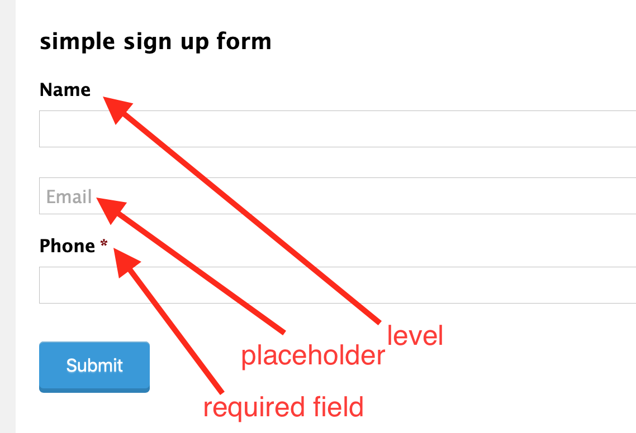

## **/////G\\\\ Phone Formatting :**

==============

USA : (###)###-####: (144)347-8879  
**** **International: any phone number (Use this one always for phone)**

**Form Description:**

write any coution message - what you want to show during form filled up

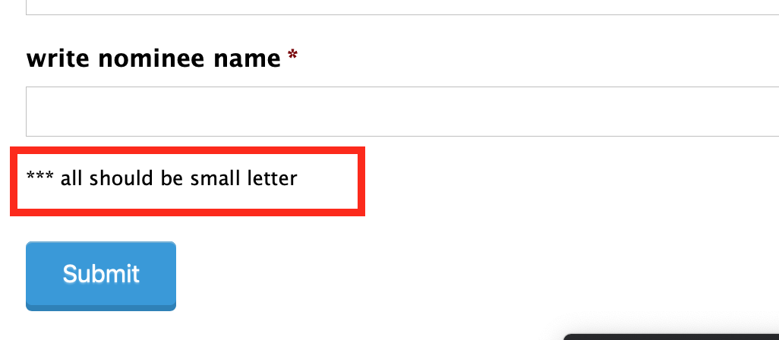

**Error Message Configure**

Edit form field > appearance > **Custom Validation Message: “write the error messages”**

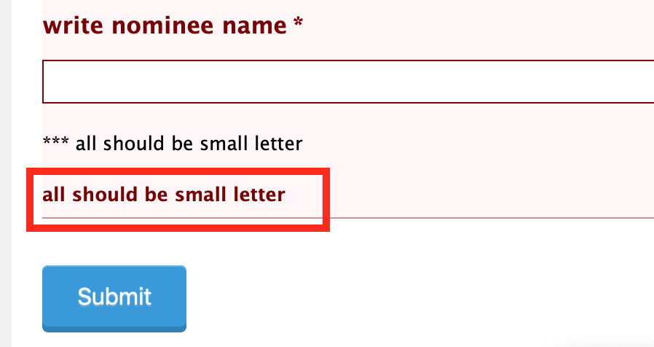

**>>> Given Dropdown Field & Bulk Import for choice:**

**> add dropdown > choose Bulk >**

**> get all countries**

**> all US states**

**> all gender choice**

**all cities**

**> all age group**

**>>> Bulk Upload - Dropdown/ Radio/ Multi Select**

* **Take a dropdown/radio/multi select field**
* **At choice option there are “BULK ADD”**
* **Now at right there are : BLANK FILED**
* **Option-01: Copy Paste - 1000 Choice from excel**
* **Option-02: At left pre defined bulk options (like all countries / all zip US)  
  YOU CAN USE ANY ONE FOR BULK CHOICE OPTION INSERTING**

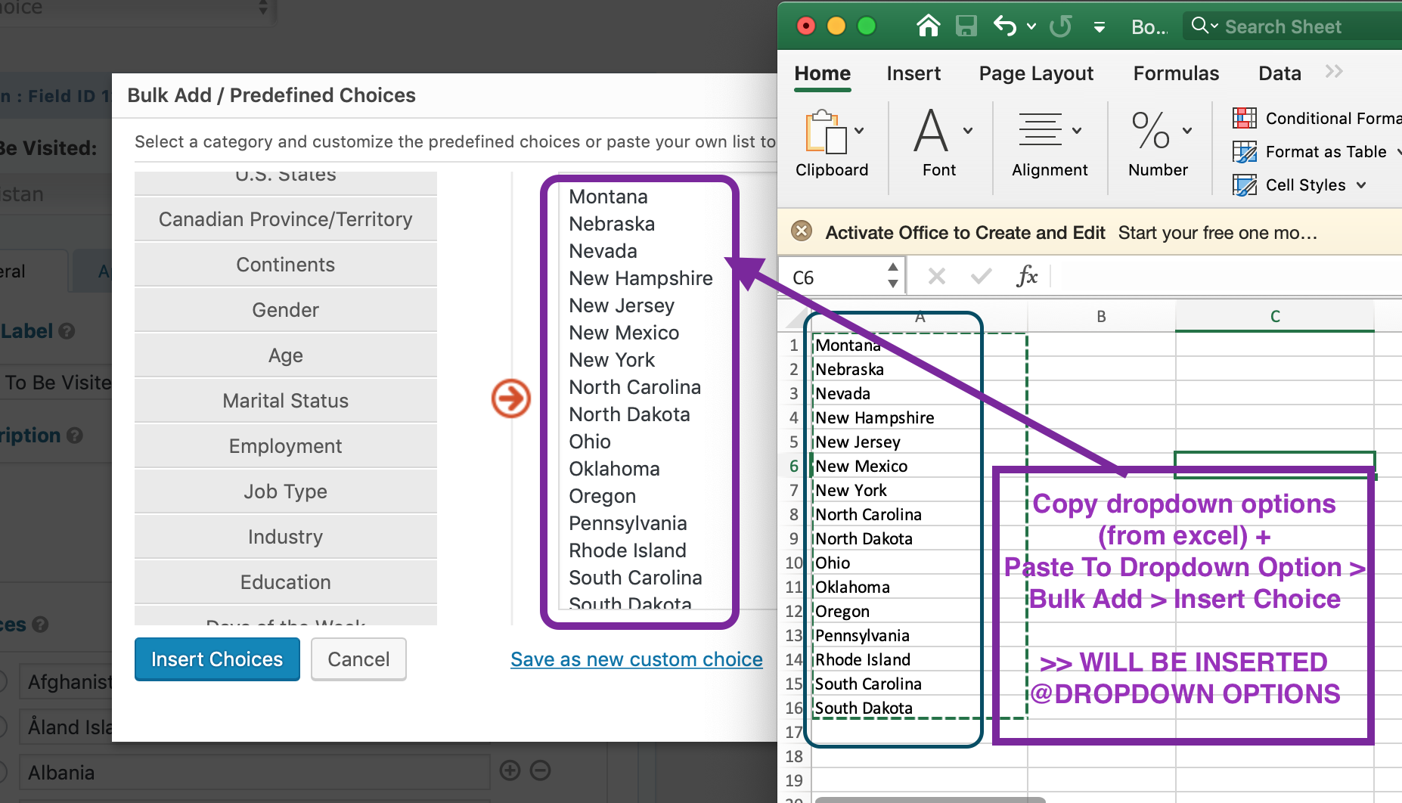

**>>> Input Musk**

* If email field chose : it will required : @ .com
* Only numbers (max 5 characters) like this

**>>> Configure Input Musk**

* Add a “single line text”
* Tick -> input musk
* Custom musk ->

**>>> Custom Input Musks**

* If **alphabet(Upper/Lowercase) both** -> write **\***

(ex: Minhaz ASIF)

* If **alphabet(Lowercase) both** -> write **a**

(ex: minhazul asif)

* If **numeric** -> write **9**

(ex: 01871993300)

* If **date format** -> write **9**

(ex: format will be : dd/mm/yyyy: **input musk: 99/99/9999)**

(ex: format will be : dd/jan/yyyy: **input musk: 99/aaa/9999)**

* If **limit character(max character fix)** -> **aaaa or **** or 9999**

(ex: 4 letter : asif)

Phone:   
@description: **Format: (+880)-XXXX-XXXXXX**

Input musk : custom: (+999)-9999-999999

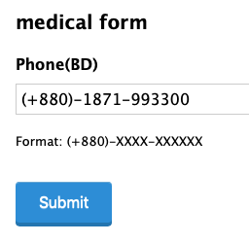

**/////G\\\\Form Design : 01 :**

* **Simple Signup/ contact Form   
  ====/////====/////====/////====**

**Process**

**=========**

* Name
* Email
* Phone
* Message
* Gender : radio - Male/ Female / 3rd Gender
* Course: Dropdown - wp/ web / lead
* Checkbox, I agree

How to add and design a gravity form at a page

=========================================

* Install & activate essential elementor addons
* From wp dashboard > click essential addons
* Click: elements > ENABLE ALL > Save Changes
* Create a page edit with elementor > add “EA GRAVITY FORM”
* Now choose - the gravity form - that you created
* ENABLE : Custom Title & Description : write “preferred title”
* DISABLE: Title
* Settings > page layout : elementor full width
* Edit EA Gravity Forms > Style
* ENJOY UNLIMITED CUSTOMIZATION
* Form container : background color: + add padding + form width
* **Input & Textarea: input box background color + text color + input width + SPACING**
* **SUBMIT BUTTON: fill width + background color + text color**
* **Error message : text color : RED**
* **Radio & Checkbox: Custom Style > increase size + color & checked color**
* **Thanks you message - color + font + color**

**Lecture -02**

**================**

**/////G\\\\Form Design : 02 :**

* **Multi Section Form   
  ====/////====/////====/////====**

**Process**

**==========**

**> add section: personal info**

**---------------------------------------**

**- name**

**- Email**

**> add**

**section: company info**

**---------------------------------------**

**- company name**

**- job title**

**> add section: education info**

**---------------------------------------**

**- university name**

**- subject**

**/////G\\\\Form Design : 03 :**

* **Multi Step Form   
  ====/////====/////====/////====**

**Process**

**=========**

**> Add some page break**

**> add page break: personal info**

**---------------------------------------**

**- name**

**- Email**

**> add page break: company info**

**---------------------------------------**

**- company name**

**- job title**

**Custom Css Class**

**======================**

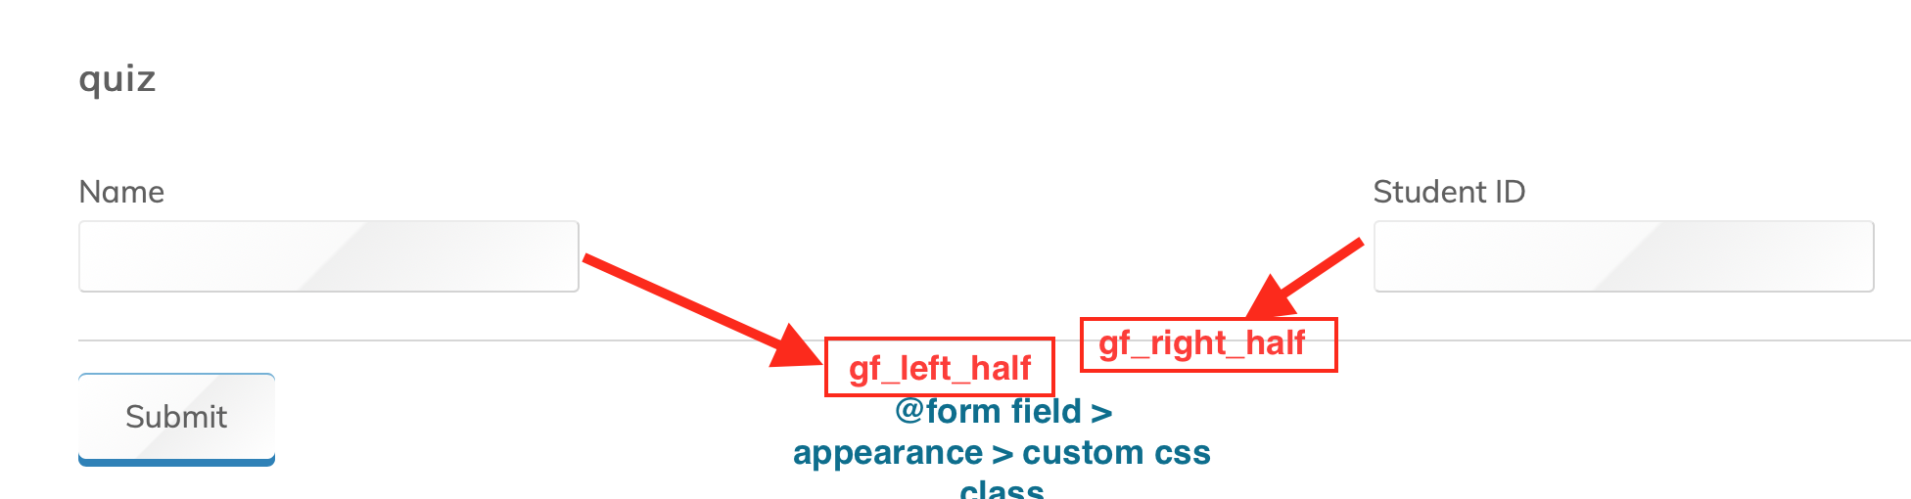

**Process**

**===============**

* **Add 2 form fields : “NAME” & “EMAIL”**
* **As general - both will show one after another**
* **Edit each field > Go Appearance > Custom Css Class:**
* **@Name, write: gf_left_half**
* **@Email, write: gf_right_half**
* **Now you will see : both filed : at a single row/ line**

**Confirmation message**

**==============**

* **Go to form > edit >**
* **Settings > confirmation > default confirmation edit >**
* **Paste msg that client give you**

**Text**

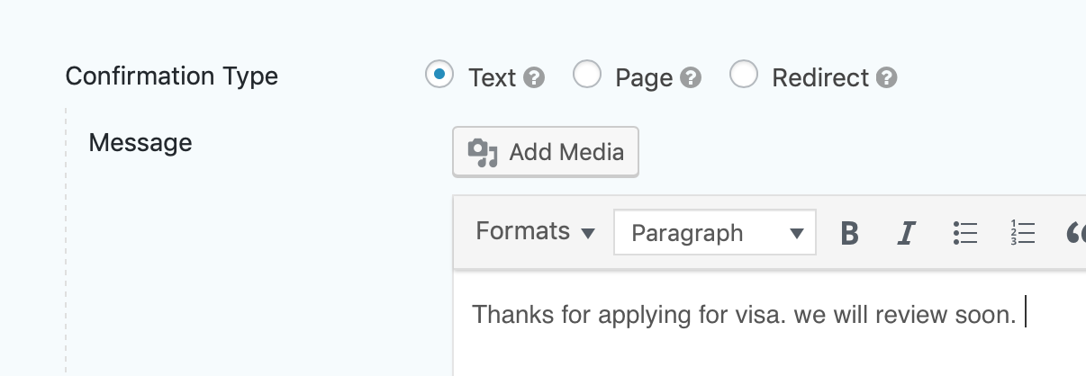

**Page**

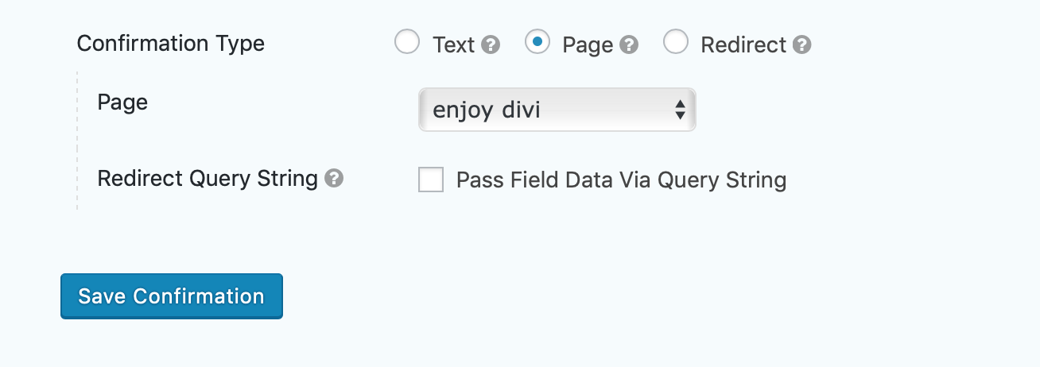

**Redirect**

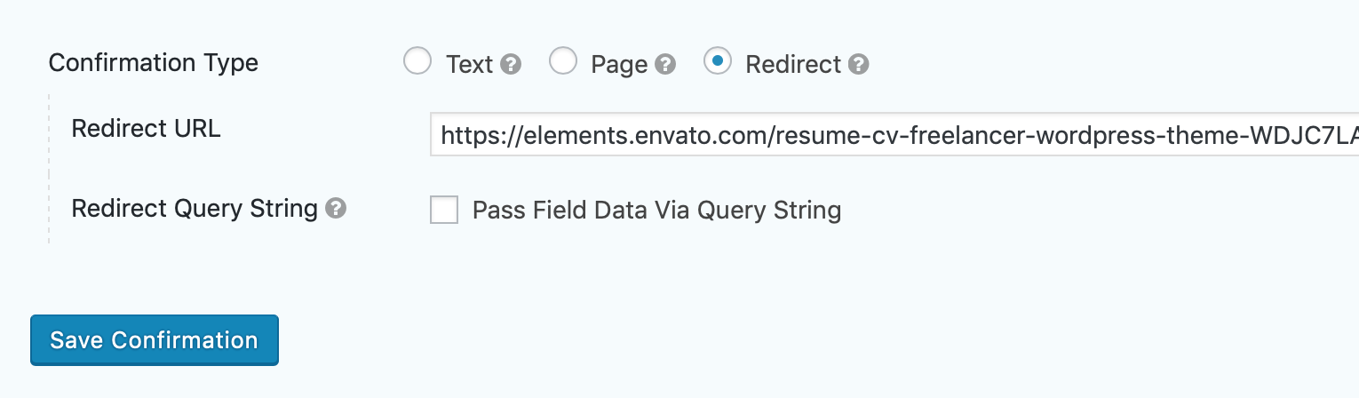

**Admin Notification**

**===================**

* **this is the admin email that website owner will get**
* **default wordpress dashboard admin email treated as admin email**
* **you can change “ from email”**
* **change subject**
* **change personal admin email body**
* **by default viewer data that is filledup by viewer go to admin email**

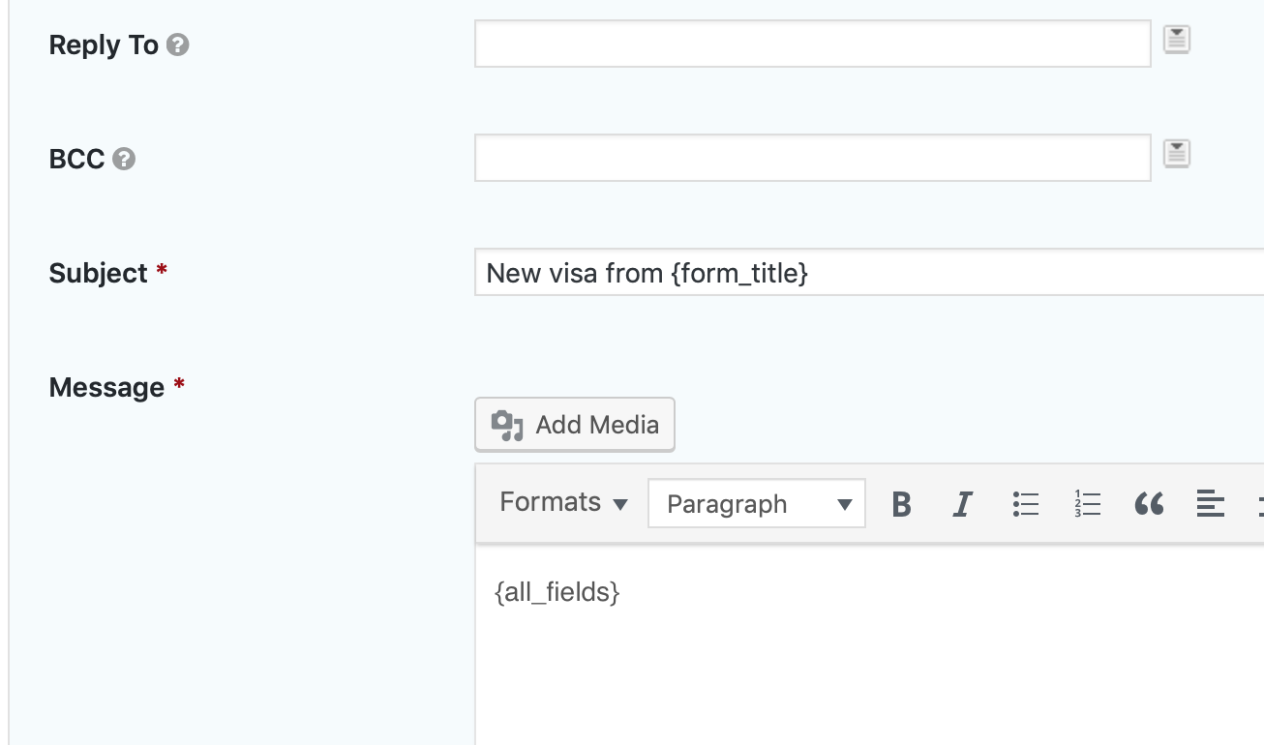

**/////G\\\\Form Design : 04 :**

* **Gravity PopUp Maker  
  ====/////====/////====/////====**
* **Get this free:** [**https://wordpress.org/plugins/popup-maker/**](https://wordpress.org/plugins/popup-maker/)

**Process**

**========================**

* **Create a General form which we want to to show at on click popup**
* **install popup maker plugin**
* **from dashboard click popup maker add > new popup**
* **give a title “form pop up”**
* **ADD A GRAVITY FORM to the pop up content**

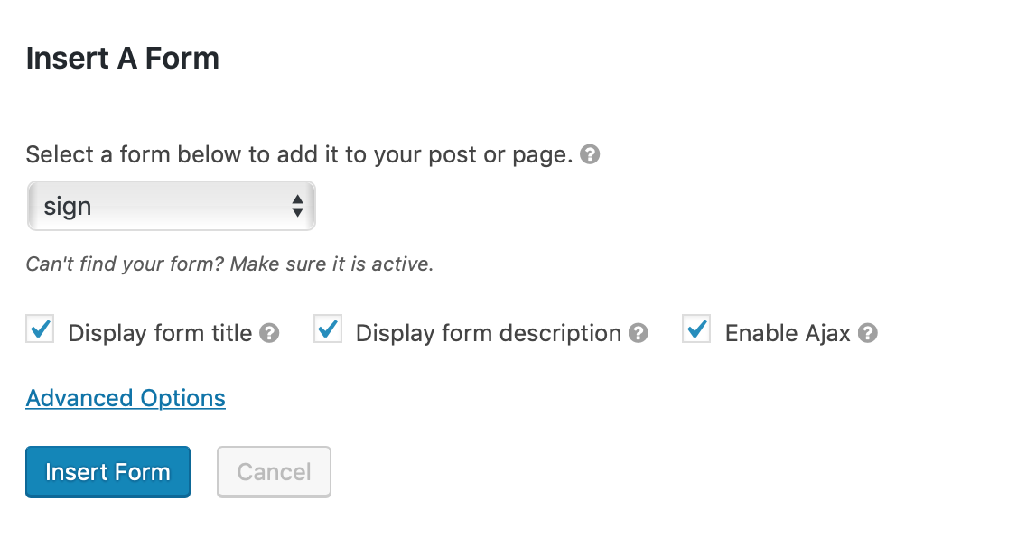

* **TRIGGER > ADD new trigger > auto open**
* **Targeting: choose page/ pages where you want to show the popup**
* **Display > center pop up**
* **When you click on the button the gravity form will be popped up**
* 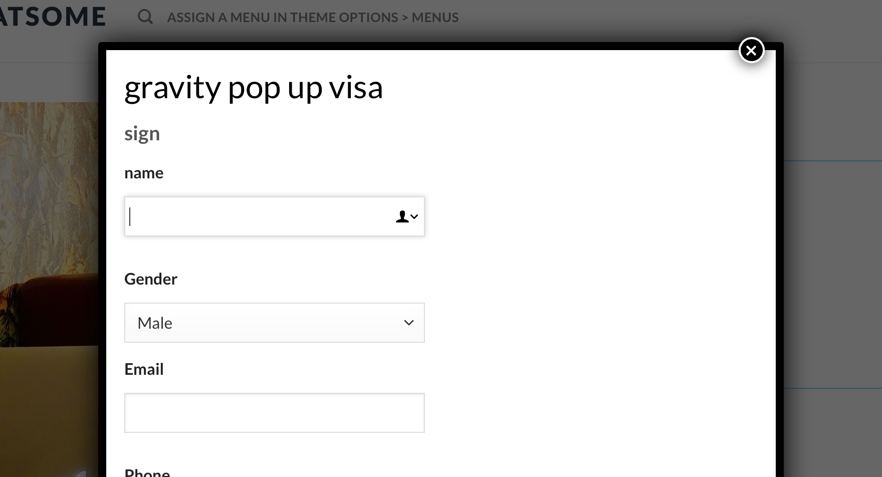

**For click open**

**==============**

* **Trigger: click open: Extra CSS Selectors : .popupbyminhaz**

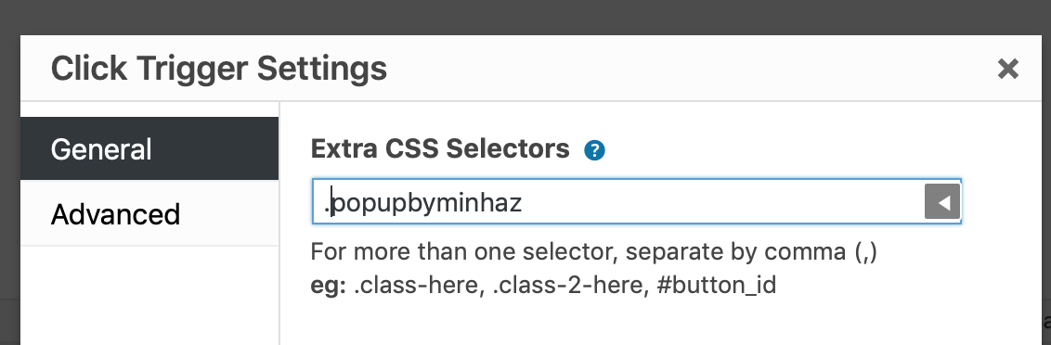

* **Create a page/ design it/ there is a button: go advance > CSS: popupbyminhaz**
* **When you click on the button the gravity form will be popuped**

## 

## **ASSIGNMENT**

**Complete the forms same to same**

**Simple customize the design by essential addons & make it same as the picture**

**Form - 1  
=========**

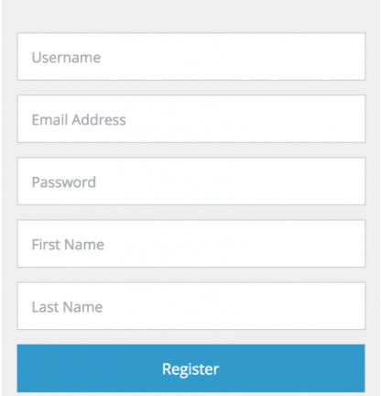

**Form - 2  
=========**



**Form - 3**

**==========**

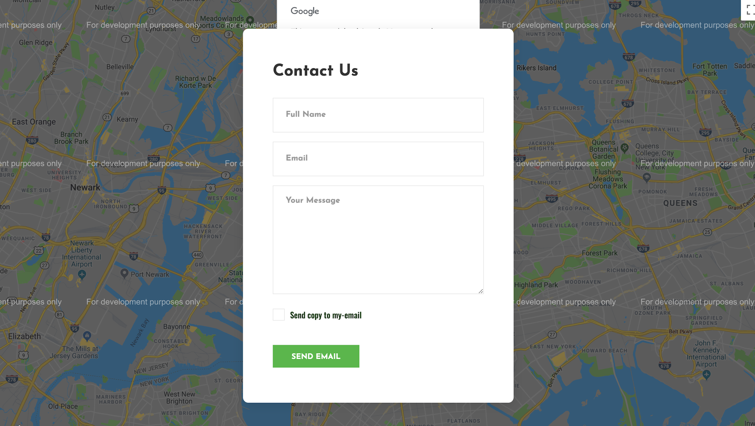

**Form - 4**

**==========**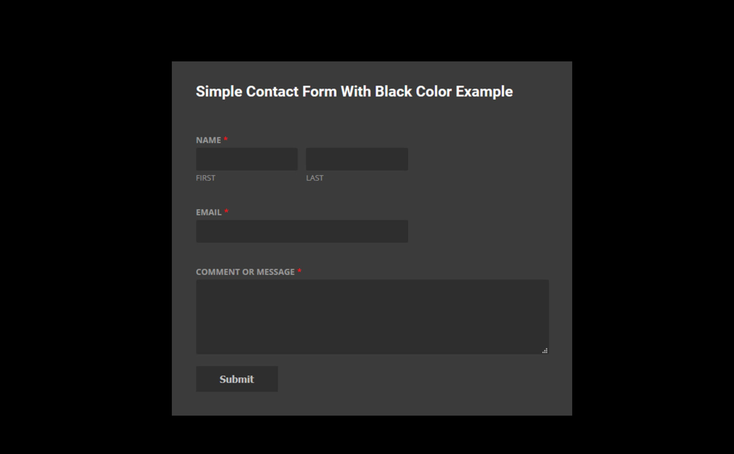

**Form - 5**

**==========**



**Form - 6**

**==========**

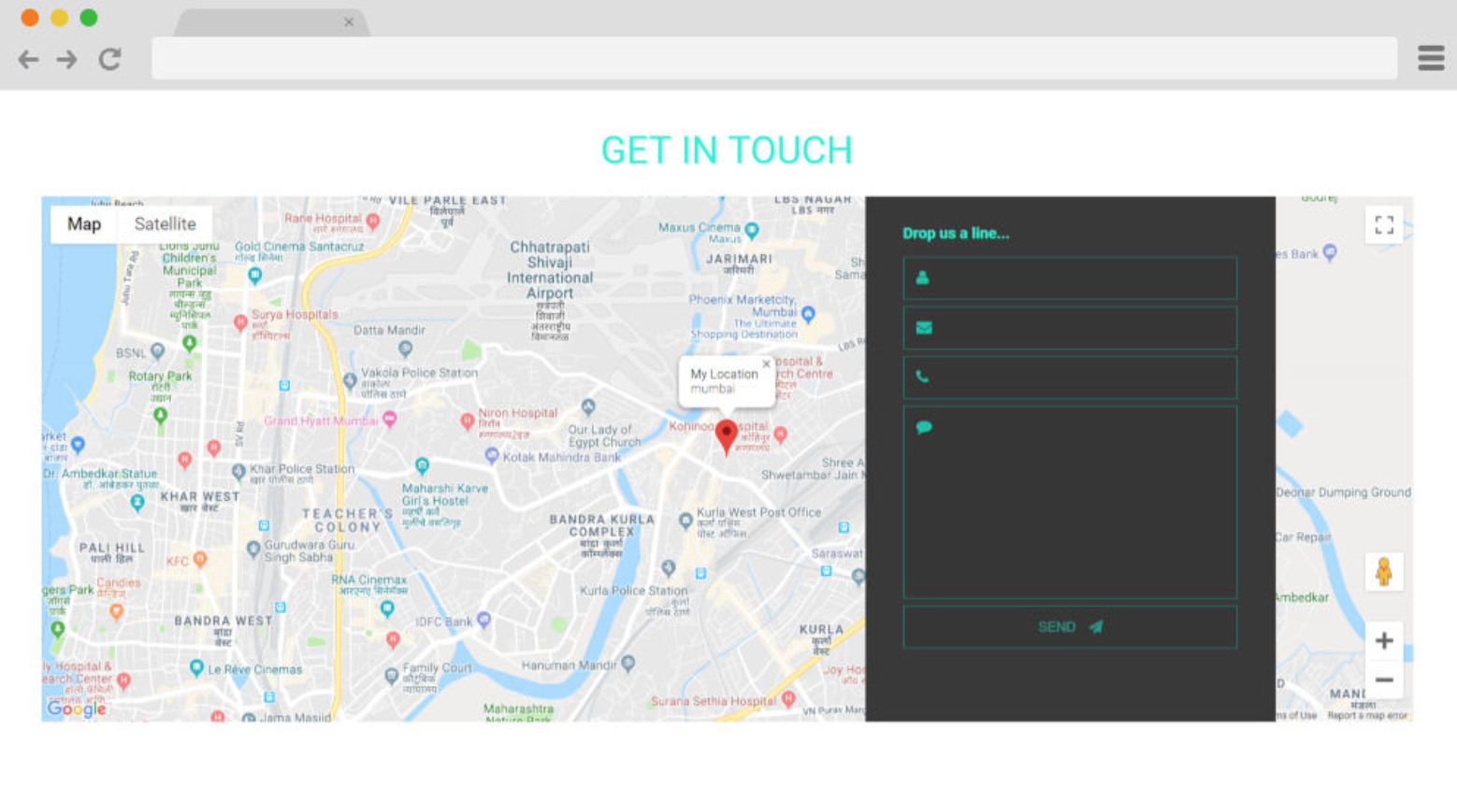

**Form - 7**

**==========**

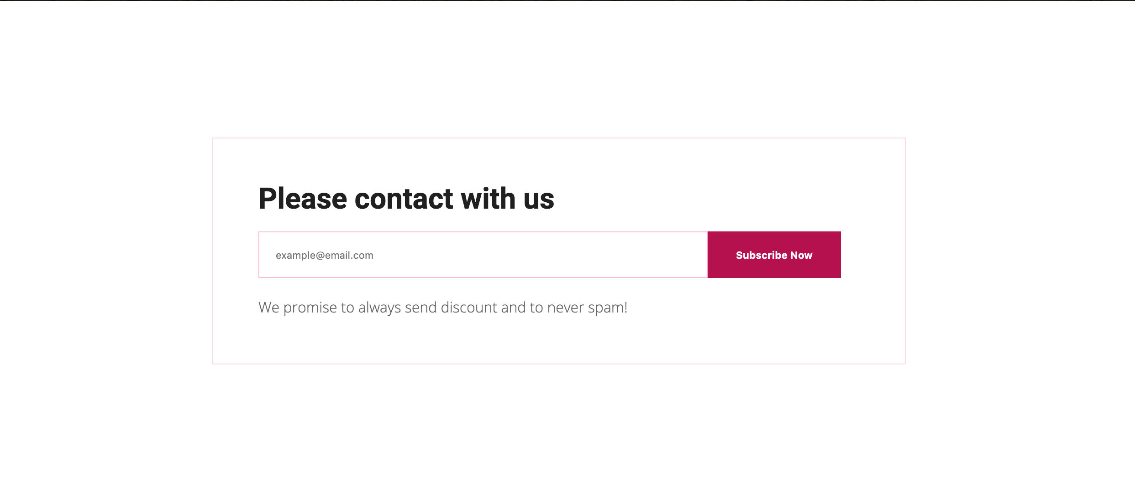

**Assignment 20**

**===============**

**Form-01**

**----------------**

**create a form with name email and phone**

**when the form it will redirect to a YouTube video**

**Form-02**

**-------------**

**create a multi step form**

**at first part it will show personal information with name email phone**

**at second part it will show educational information - graduation/under graduation/ hsc/ssc**

**> thank you message will confirm**

**Form 3**

**------------------**

**create a onclick popup bye popup maker plugin**

**when anyone click a image**

**it will show a gravity popup form with**

* **name/**
* **country(SHOW COUNTRY LIST) /**
* **COURSE DROPDOWN(OPTIONS : WEB DESIGN/WORDPRESS)**

**/////G\\\\Form Design : 05 :**

* **Mailchimp For Gravity  
  ====/////====/////====/////====**

**Process Of Create a form & integrate with mailchimp Addons**

**===================================**

* **Create form**
* **Install - Gravity Mailchimp Addon(as plugin)**
* **Signup mailchimp.com > account > extras > api key  
  (**[**https://us19.admin.mailchimp.com/account/api**](https://us19.admin.mailchimp.com/account/api)**)**
* **Create A key > copy this & paste at Gravity form > mailchimp settings  
  (Gravity form > settings(main) > mailchimp > )**
* **Form > edit your form > setting > mailchimp > create one!**
* **MailChimp List: select audience from 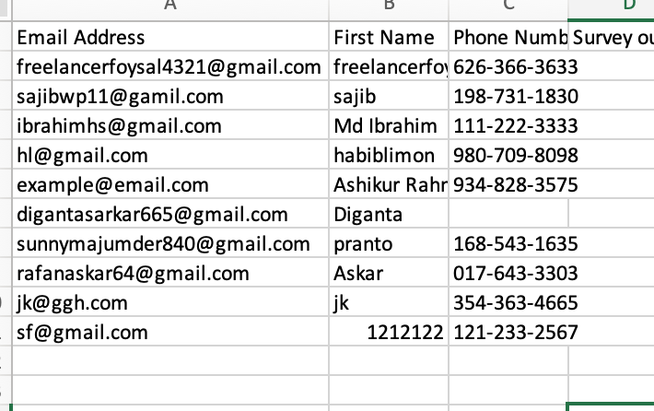dropdown >**
* **Map Fields: email / first name / phone : show them from dropdown**
* **Disable : double optin**
* **Now put form at a page , if anyone filled up the form**
* **Name - email & phone will go at mailchimp - audience**
* **Mailchimp > Click audience number > select all > export > csv > get all data**

**/////G\\\\Form Design : 06 :**

* **Gravity Styler Pro  
  ====/////====/////====/////====**

**Process of Creating a form & design with “STYLER PRO”**

**========================================**

* **Install gf styler pro addon as plugin**
* **Gravity form > main settings > default theme: choose one(classy) + Universal Settings: choose that theme : classy + custom css: ON + Reinforce customization: Tick**
* **Create a form**
* **Go form settings > styler pro > choose : same theme**
* **+ enable icon: font awesome**
* **First name - last name**
* **Go appearance > style form > half - half both**
* **See the both fields will be at 1 row**
* **Choose filed icon > color icon**

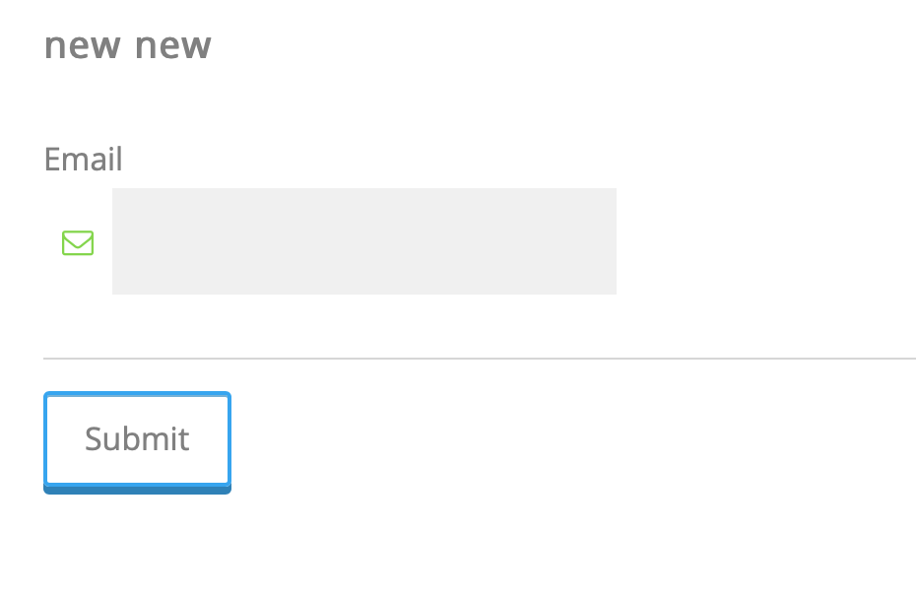

**/////G\\\\Form Design : 07 :**

* **Gravity Product Payment Calculate & Paypal Addon  
  ====/////====/////====/////====**

**Process - Paypal payment form**

**==============================**

* **Install gf paypal**
* **Form > settings > paypal > i agree(Tick) > save**
* **Create form > settings > paypal > create one >**
* **Add email : of client paypal account: ex:** [**minhaz.freelance@gmail.com**](mailto:minhaz.freelance@gmail.com) **+ transaction type: products**
* **Edit form >**
* **Name**
* **Product: (Multiple )name of the product + field option: dropdown :**

**------ product - price**

**----------------------------------**

**----- 1 komola : $10 --- price: $10**

**----- 2 komola : $15 --- price: $15**

**----- 3 komola : $25 --- price: $25**

* **Product: (customer will write amount )name of the product + field option: single :**

**------ product - price**

**----------------------------------**

**----- apple : $15**

* **Add a total field > to calculate the price**
* **Update > preview > enjoy !**

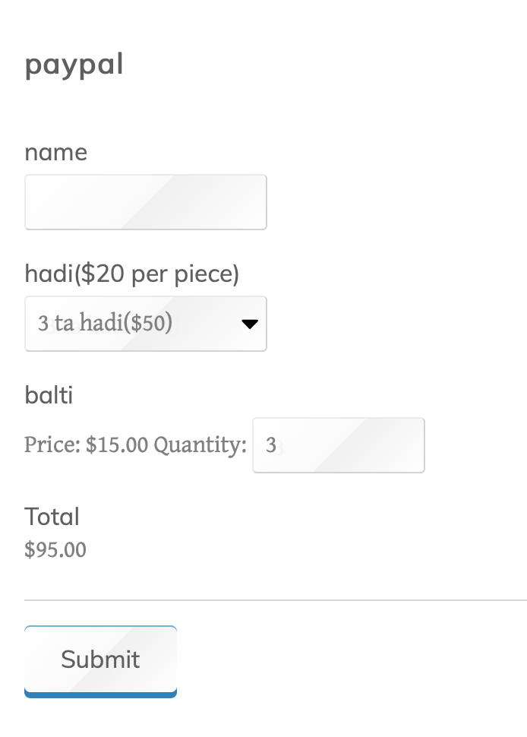

**/////G\\\\Form Design : 08 :**

* **Gravity Paypal & Stripe MasterCard | Conditional Logical Payment  
  ====/////====/////====/////====**

**Process - Paypal & MasterCard (Logical) payment form**

**===========================================**

* **Install gf paypal & gf stripe adons**
* **Form > settings > paypal > Tick/ Confirm: PayPal IPN Setting > save**
* **Form > settings > stripe > Stripe API: Test >   
  *\*\*\* Publishable API Key: (client will give you)  
  *** Secret API Key: (client will give you)***
* **Payment Collection Method: Gravity Forms Credit Card Field**
* **Stripe Webhooks Enabled?: Tick/ Enable**
* **Create form > add first name - last name - email - phone - address - city - state - zip - country - product 01 - product 02 - total**
* **Add a field : “Choose payment method” - add 2 - dropdown option : PAYPAL + STRIPE**

***ADD CREDIT CARD & APPLY PAYMENT LOGIC***

* **Add field > credit card >**
* **Go advance option of “credit card” > enable conditional logic >**
* **SHOW ALL :   
  ** CHOOSE PAYMENT METHOD : IS -> “STRIPE”**



***CREATE PAYPAL FEED***

* **Edit form > Settings > paypal > add new feed**
* **Paypal email > (client’s paypal login email address - client will give)**
* **Edit form >**
* **Add email : of client paypal account: ex:** [**minhaz.freelance@gmail.com**](mailto:minhaz.freelance@gmail.com)
* **Mode: TEST**
* **Transaction Type: Products & Services**
* **Payment amount : form total**
* **Billing Information: match : first - last - email - phone - address**
* **Cancel URL:** [**www.xxx.com/products**](http://www.xxx.com/products)
* **Enable Conditional Logic**
* **SHOW ALL :   
  ** CHOOSE PAYMENT METHOD : IS -> “PAYPAL” > Update Settings**

***CREATE SYRIPE FEED***

* **Edit form > Settings > stripe > add new feed**
* **Stripe feed name: pay via stripe**
* **Transaction Type: Products & Services**
* **Payment amount : form total**
* **Enable Conditional Logic**
* **SHOW ALL :   
  ** CHOOSE PAYMENT METHOD : IS -> “STRIPE” > Update Settings**

**Gravity Form Advanced - Activities**

**===============================**

**/////G\\\\Form Design : 09 :**

* **For Gravity Live Population  
  ====/////====/////====/////====**

**>> Task : Populate Value At Level/ Value & Placeholder**

**>> Documentation:** [**https://forgravity.com/documentation/live-population/poTFGVBpulating-a-field-label/**](https://forgravity.com/documentation/live-population/populating-a-field-label/)

**>> REQUIREMENTS**

**======================================**

* **FOR GRAVITY LIVE POPULATION ADDON**

**Process Of Gravity Form - Live Population**

**======================================**

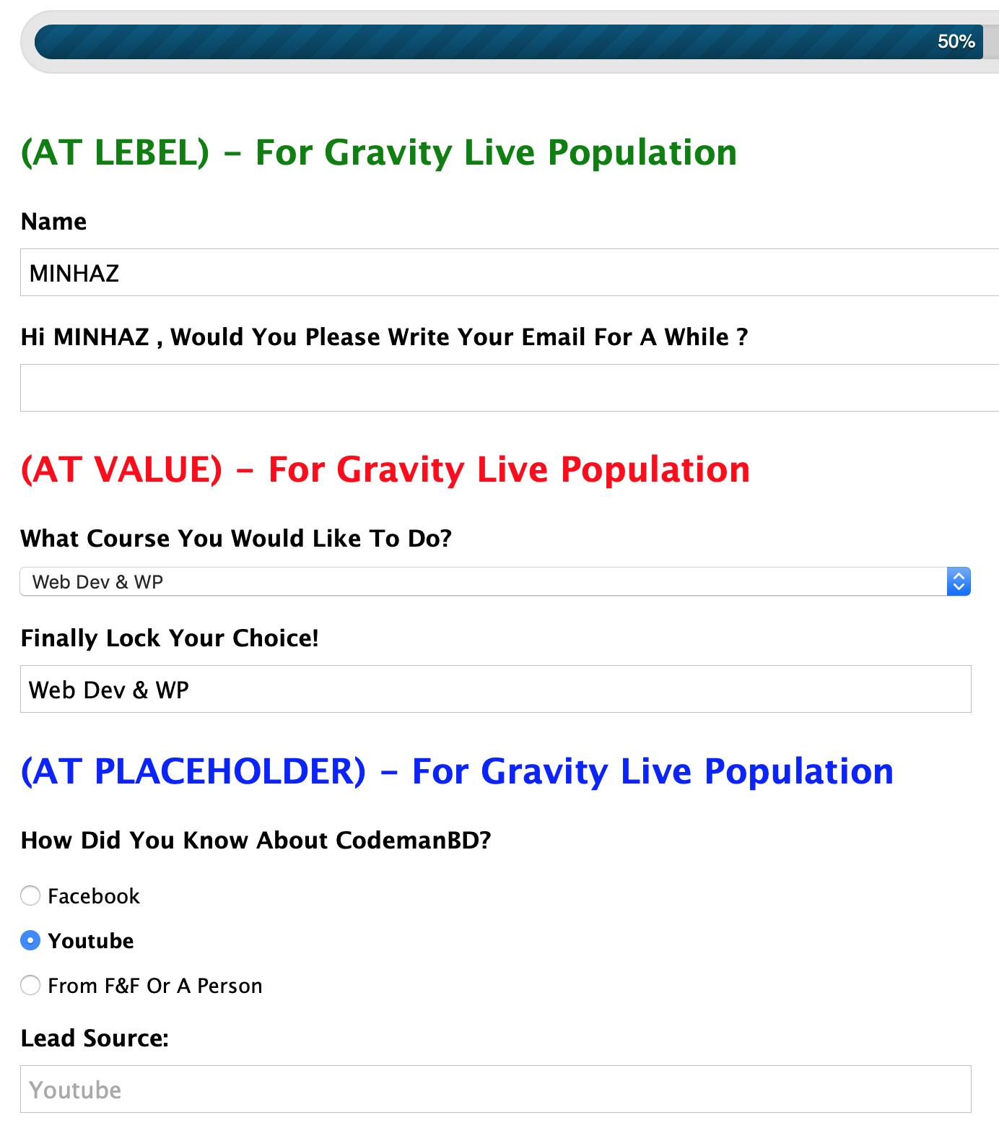

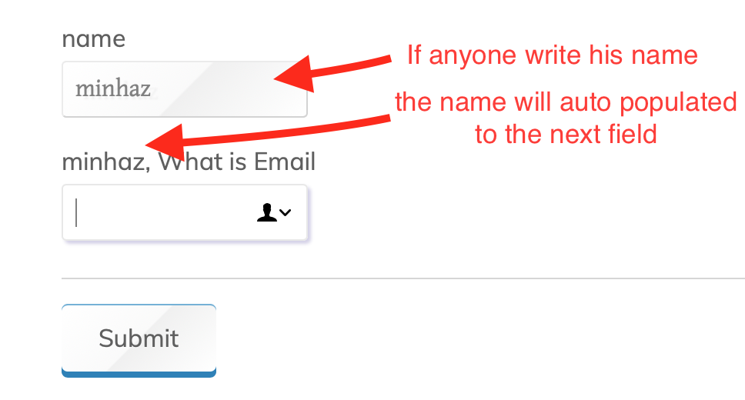

**Collect Data By Hidden Field: (Live Population From Previous DropDown)**

**How To Add & Collect Data - By A Hidden Field**

**=========================================**

* **Standard Fields > Hidden >**
* **Give A Lebel(Data Source) >**
* **Click > Live Population > Tick: Allow merge tags + Tick : Field VALUE >**
* **Advanced > Field Value: {field name : ID}**
* **SO IF ANYONE - WANT TO KEEP A DATA FROM A FIELD, AND USER WILL NOT SEE THIS, THIS IS THE WAY,**

**NB: similar: tracked time, tracked ip & current location**

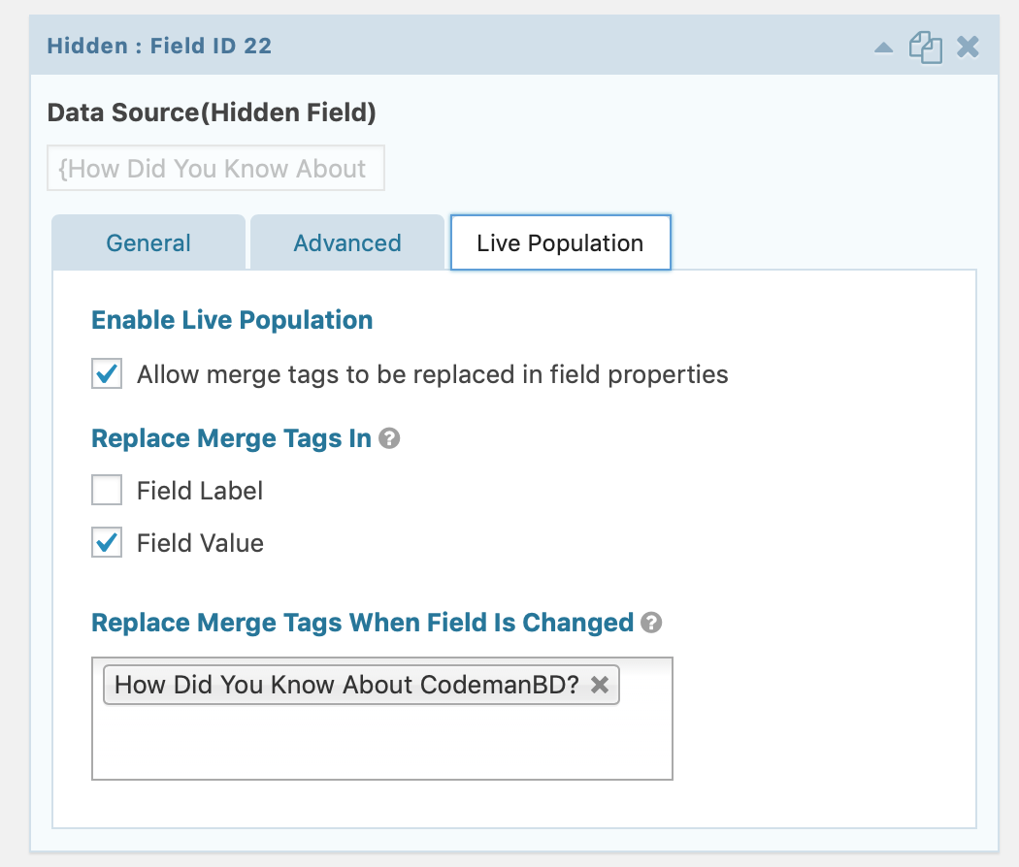

* **First field is asking for name: if anyone write his name, say: Minhaz**
* **the next field Auto populate the name and I speak for email(see pic above) - ex: Minhaz(auto Populated), What is email**

**Configuration**

**===============**

* **Install - “for gravity - live population” addon**
* Take a single field, level: name
* Take another single field
* FOR 2ND ONE -> Click the **Live Population tab.**
* Select **“Allow merge tags to be replaced in field properties checkbox”**
* Select “**Replace Merge Tags In Field Label checkbox.”**
* Select CHECKBOX **Replace Merge Tags In Field Label” -** and **write the level of previous field**(from where data will populate)
* Click the **General tab.**
* Enter in **merge tags** in the Field Label setting.

**How to write ”merge tags”:  
Generic:** {Previous field level:field ID}  
**Example: {name:1}**

**Sample Picture**

|  |  |
| --- | --- |

**  
  
Another Sample of live population:  
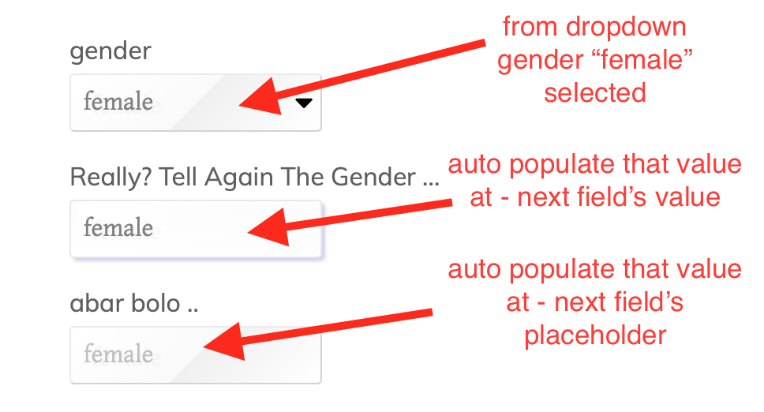**

**/////G\\\\Form Design : 10 :**

* **Gravity Perks Preview Submission  
  ====/////====/////====/////====**

**What is this ?  
===============**

* **If anyone complete the form, before submission he can see the form for checking**
* **finally he can submit or edit the form**

**DEMO**

**=======**

* **https://demos.gravitywiz.com/gp-preview-submission/**

**Requirements**

**===============**

* **Gravity Perks**
* **Gravity Perks Preview Submission Addons**

**Procedure**

**===============**

* **add a “Page Break” field AT VERY BOTTOM of the fieldad**
* **Add an HTML field AFTER THE “Page Break”**
* **Click this HTML field to EDIT**
* **beside “Content” get a “small icon”**
* **Click this icon to select “All Submitted Fields” option.**
* **Save the form.**
* 

|  | **Previous: EDIT Submit: FINALLY SUBMIT** |
| --- | --- |

**/////G\\\\Form Design : 11 :**

* **Gravity Quiz & Survey  
  ====/////====/////====/////====**

**Tasks: Instant Ans-Marks / Grade/ Pass-Fail Calculate**

**What Is It ?**

**===============**

* **MCQ question/quiz**
* **Instant correct answer show**
* **Total marks show/ Grade/ Pass-Fail Show (After Submit)**

**Requirements**

**===============**

* **Gravity Quiz Addon**

**Process & Configure**

**=====================**

* **Install & Activate Gravity Quiz Addons**
* **Create new form**
* **Name, batch, email ..**

**QUIZ FIELDS**

**==============**

* **Add a “quiz field” from advanced fields**
* **Now : write question at level**
* **At radio Button - there are 3 options as MCQ & ADD values at radio options**
* **MARK THE CORRECT OPTION (TICK)**
* **ENABLE/ CLICK : “WEIGHTED SCORE”**
* **@WEIGHT: PUT MARKS FOR CORRECT ANSWER : example: 10**
* **@WEIGHT: PUT MARKS FOR WRONG ANSWER : example: 0**
* **Enable answer explanation: NB: WRITE HERE THE TRUE ANSWER, ALSO YOU CAN EXPLAIN WHY ITS TRUE!**

**In this sequences add - 10 questions and configure - QUIZ answers & marks > UPDATE**

**FORM SETTING > CONFIRM MSG >**

**==========================**

**\*\*\* NB: For quiz results : you must disable (default confirmation text message)**

**> Form settings > confirmation > default confirmation**

**> edit > remove the message given there**

**SHOW MARKS / PASS/FAIL / GRADE**

**===================================**

* **After form create & edit > click form settings > QUIZ**
* **ENABLE/ TICK: Shuffle quiz fields**
* **ENABLE/ TICK: Instant feedback**
* **Click : Pass/Fail**
* **Set Pass Percentage : ex: 80% (means - if he get 80% marks : he will pass)**
* **Quiz Pass Confirmation: You Passed!**
* **Quiz Fail Confirmation: You Failed!**

**(NB: Click right toggle icon : to get variations of Quiz Result)**

**Quiz Pass/ Fail : Results Format**

**===================================**

**Option-01: Congrats you: {quiz_passfail}**

**Option-02: Your Result Grade Is: {quiz_grade}**

**Option-03: You Got Marks(Percent%): {quiz_percent}%**

**Option-04: Total Score: {quiz_score}**

**Option-05: Get Results & Correct Answer Details: {all_quiz_results}**

**You passed!**

**OUTPUT QUIZ CONFIRMATION**

**=============================**

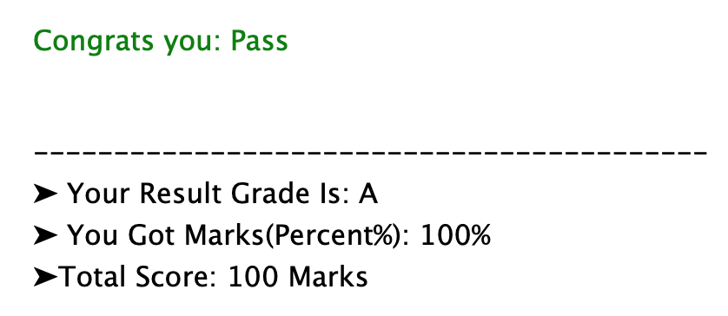

**/////G\\\\Form Design : 13 :**

* **Gravity PDF  
  ====/////====/////====/////====**

**Tasks: form data - after submission make submitted data to pdf & download pdf option**

**Get plugin:** [**https://wordpress.org/plugins/gravity-forms-pdf-extended/**](https://wordpress.org/plugins/gravity-forms-pdf-extended/)

**>> downgrade pdf plugin**

**>> download core fonts (settings > pdf > tools > fonts )**

**>> form settings > pdf >**

**>> name: write a name like: “subscribe form”**

**>> file name: after download pdf file name: like: “subscription form pdf”**

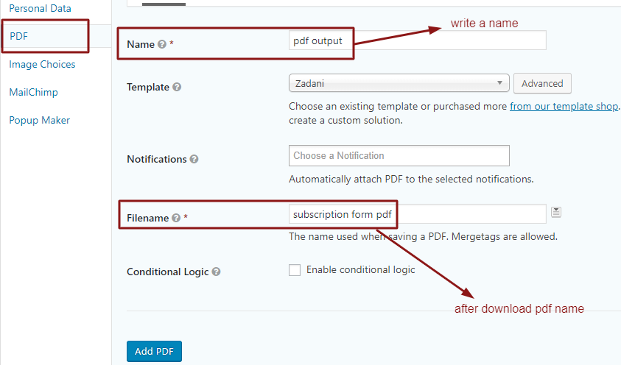

**>> settings > PDF > template > header > add logo / company info**

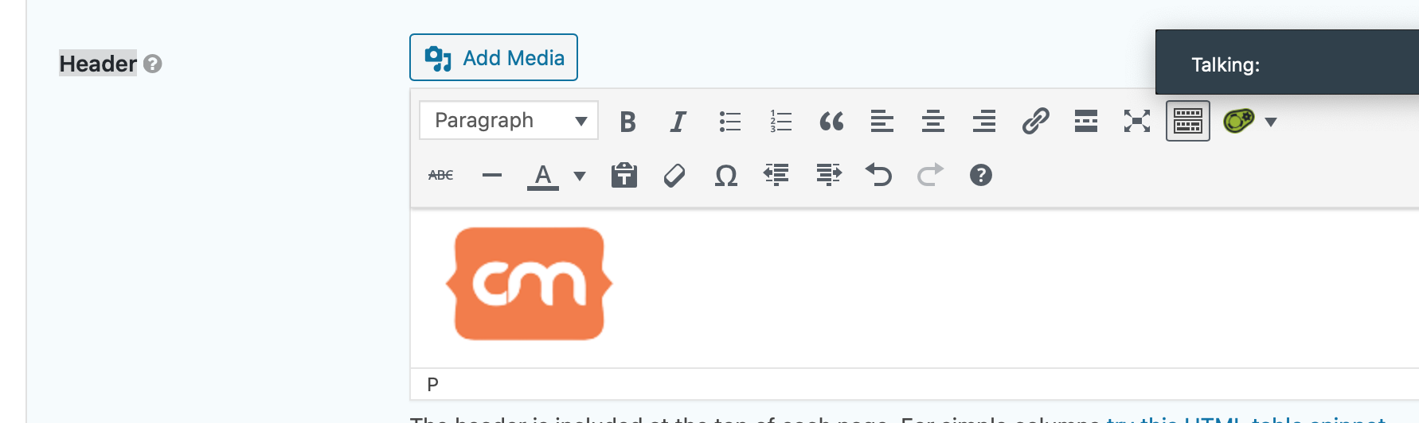

**>> save**

**>> again to settings > pdf > get pdf shortcode :   
like: [gravitypdf name="pdf output" id="5dcaf632cbdaf" text="Download PDF"]**

**>> put the shortcode at > settings confirmation > edit >**

**>> remote msg**

**>> put >> {all_field} + below put pdf shortcode**

**{all_fields}  
[gravitypdf name="subscribe form" id="5dcafb9b967a8" text="Download PDF"]**

**>> same - ta admin notification eo dibo >**

**{all_fields}  
[gravitypdf name="subscribe form" id="5dcafb9b967a8" text="Download PDF"]**

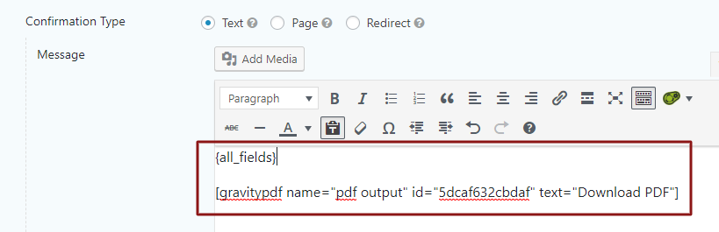

**/////G\\\\Form Design : 14 :**

* **Gravity IMAGE CHOICE  
  ====/////====/////====/////====**

**> ADD ADDONS > GRAVITY IMAGE CHOICE (gf image choice)  
> now add radio button > click use image > upload image**

**> input :**

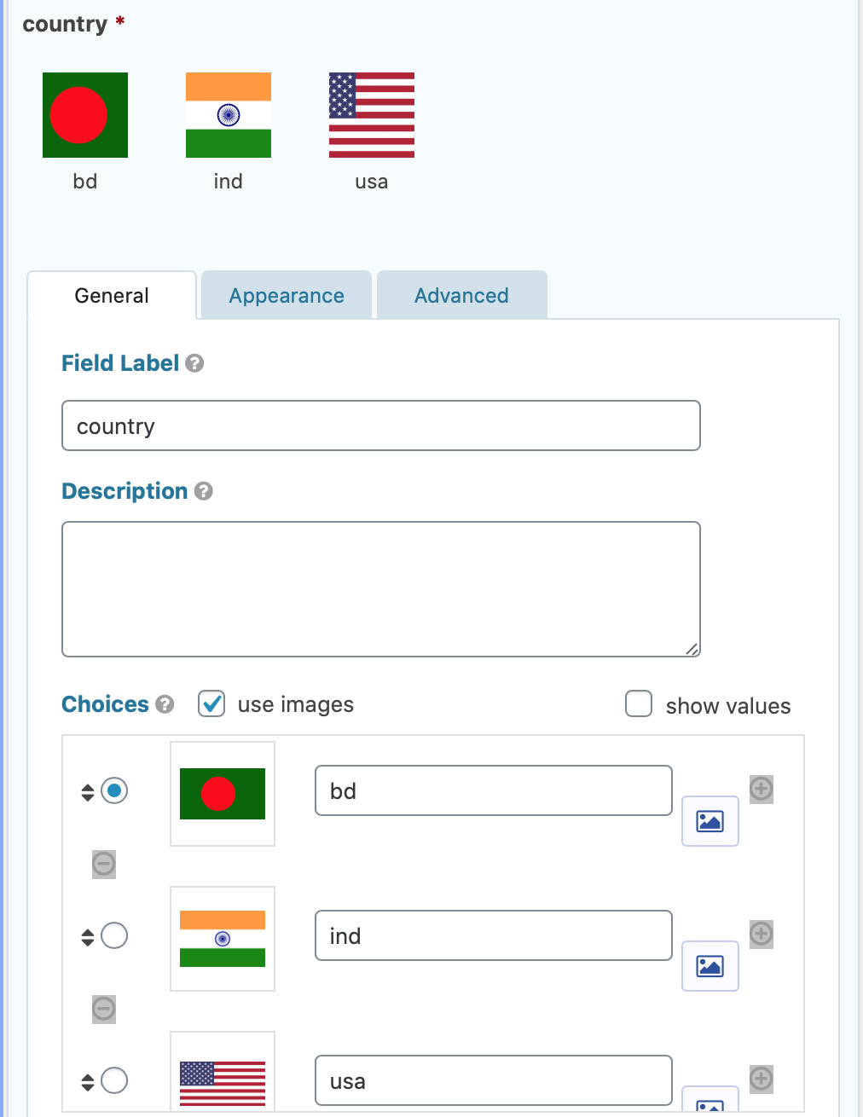

**> output:**

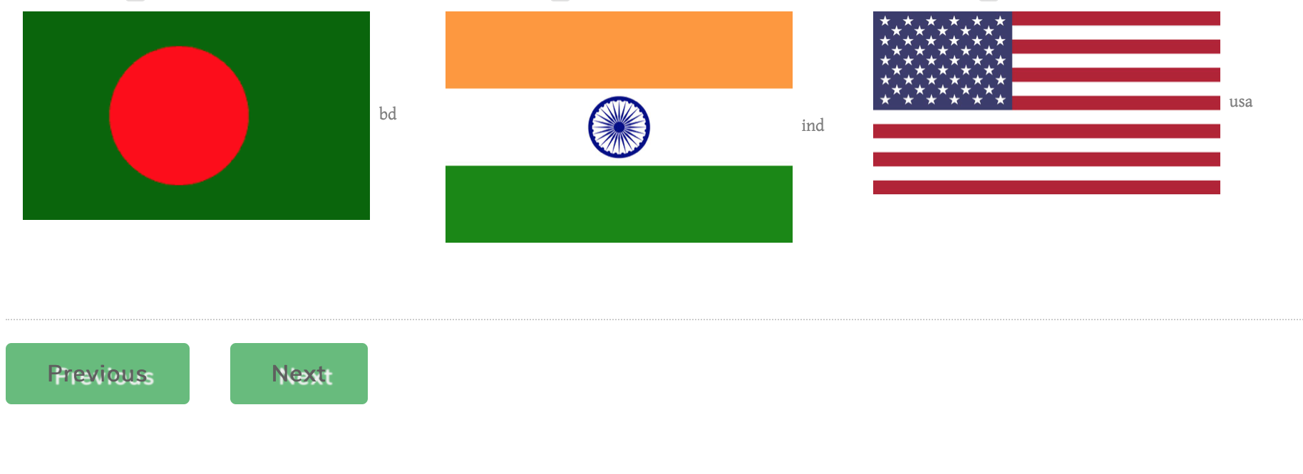

**/////G\\\\Form Design : 15 :**

* **Gravity Medical Admission Logic Form  
  ====/////====/////====/////====**

**Field-01: name   
----- page break -----  
Field-02: Choose country as image choice: BD + IND + USA   
----- page break -----  
** Condition-01: if country is BD : show Cities of BD  
** Condition-01: if country is IND : show Cities of IND  
** Condition-01: if country is USA : show Cities of USA**

**Field-03: City : dropdown : bulk upload > all bd cities (adv > conditional logic> tick > show : country > is > BD)  
Field-03: City : dropdown : bulk upload > all ind cities (adv > conditional logic> tick > show : country > is > IND)  
Field-03: City : dropdown : bulk upload > all usa cities (adv > conditional logic> tick > show : country > is > USA)  
----- page break -----  
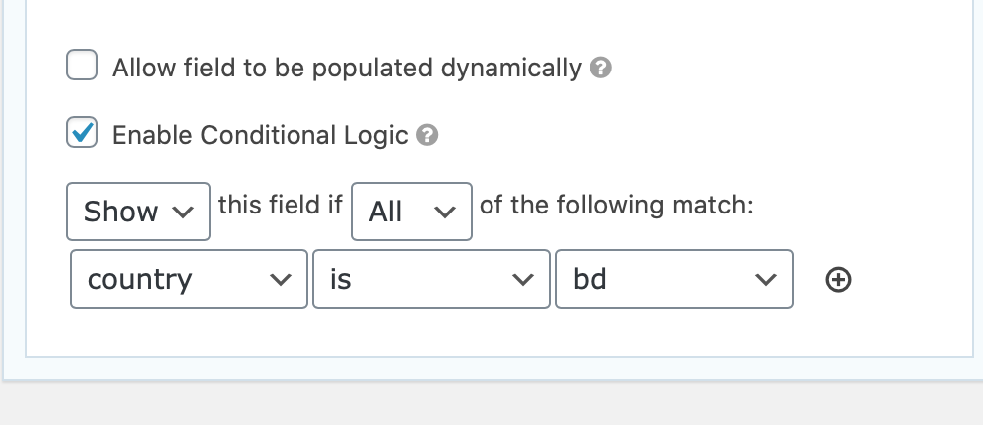**

**Field-04: HSC GPA (number field) - limit to (min: 0 - max: 5.0)**

**----- page break -----   
** Condition-01: if HSC GPA is 5 : show Manchester medical  
** Condition-02: if HSC GPA is 4.5 : show Khorokpur medical  
** Condition-03: if HSC GPA is 4.0 : show Bangladesh medical  
Field-05: medical choice: radio: Manchester medical ((adv > conditional logic> tick > show : HSC GPA > is > 5.0)  
Field-05: medical choice: radio: Khorokpur medical ((adv > conditional logic> tick > show : HSC GPA > is > 4.5)  
Field-05: medical choice: radio: Bangladesh medical ((adv > conditional logic> tick > show : HSC GPA > is > 4.0)  
  
Form Output   
-----------------  
